Building a Pi IRLP Portable Node

This document will cover the steps to create a portable IRLP Pi node. These instructions are not for MicroNodes, or cover any parts there of. A Pi node runs off of Raspian, a Debian based Linux distribution. These steps are not my own but a compilation of resources that I pulled from to make a portable node capable of using any Wi-Fi connection available, in my case a mobile hotspot.

Bellow listed is the needed equipment to build your node. I highly, HIGHLY, encourage you to purchase your initial Pi equipment through the IRLP site. This both helps provided funding to help keep projects like these supported, as well as make the whole process much faster and easier.

Needed equipment:

Raspberry Pi\*

IRLP board\*

Compatible USB Sound Card\*

4gb SD card\*

IRLP software\*

Raspbian operating system\*

Compatible Radio (I used a BF-888)

Cables for between IRLP board and Radio

Compatible Wi-Fi usb stick

12v to 5v micro usb converter

12v power source

Strong VPN subscription

Computer

HDMI compatible monitor (just for install)

Wired and Wi-Fi internet source

Some basic hand tools and soldering equipment

Time plus lots and lots of patients…..Cant emphasize this enough!

\*Included in IRLP Pi package

Steps to create Portable Pi Node:

1. Gather all the needed equipment before you start, grab some coffee and snacks and put your phone on silent for a few hours and find a good location for your build.
2. Not knowing what you are hooking your node to, I will be describing how I used a Baofeng BF-888s during this process. Once you have your radio, find a good frequency that will not interfere with others and program your radio to this.
   1. The Baofeng radio will need to be modified as well to pull the internal COS signal out to be usable for the IRLP board. See this link for a great way to modify a BF-888 for IRLP use, http://crompton.com/hamradio/baofeng888/. I didn’t do it this way, but whish I had. Also below an image of where the COS signgal is located at. I just drilled a whole in the side of the radio and ran it out that way.

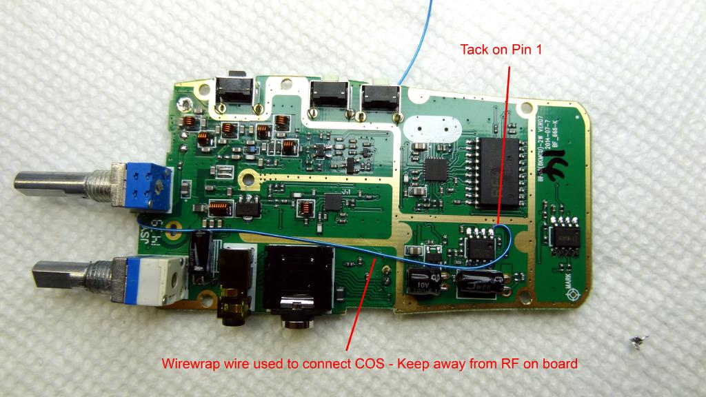

* 1. Once the radio is put all back together, hopefully working, you need a way to power it. I bought a 12v adapter for the BF-888. This adapter will also need to be modified. The internal circuitry over heats and needs to be replaced. I used a DC-DC 12v to 3.7 volt Buck converter off of Amazon. Wire the 3.7v side to the existing wires soldered to the contacts on the batter adapter, and then the 12 volt side to your power source. Reassembly adapter and hook it up to your radio. You are now powered up hopefully.
  2. Next you need to assemble your cables between the radio and the IRLP board. Here is a basic pin out for the headphone port, here is a great site with information on building a cable if you don’t want to buy a pre made one. Pre made ones are available on eBay regularly.

1. Once all your radio needs are done, we move onto the Pi Build up. The following step is only if you are doing everything from scratch. I’m not going to re hash what is already well documented, so please go here for the instructions from the IRLP site and save them to your computer. <http://irlp.net/pi/directions.txt>
2. Once the Pi is modified and software is installed follow the IRLP install manual from IRLP’s site, <http://irlp.net/pi/manual.pdf> .
3. Next we will need to conquer the Wi-Fi setup. I found these instructions to be what got me working, <https://www.maketecheasier.com/setup-wifi-on-raspberry-pi/> . Make sure you are using a compatible Pi W-Fi card as well, otherwise it just wont work.
4. Now you need to setup the VPN, follow these instructions to get you going once you have signed up with strong VPN. Make sure you have purchased the router VPN package, not just the client one. You need to be able to manipulate the ports through the VPN, explain this to customer support if needed.
5. Once you have your account, login and start setting up your server settings and port settings.
   1. First you need to select a server, select Change Server

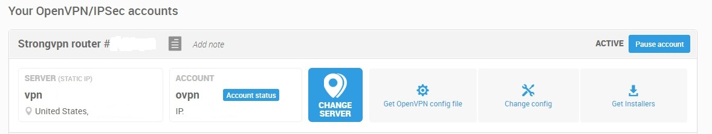

* 1. Next select Open, Choose Country, Desired City and then below select an open server

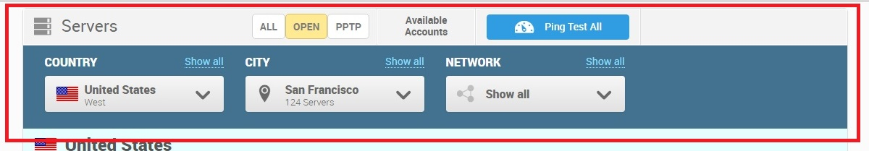

* 1. Back to the main page select Change Config
  2. In this screen select Add Custom Configuration

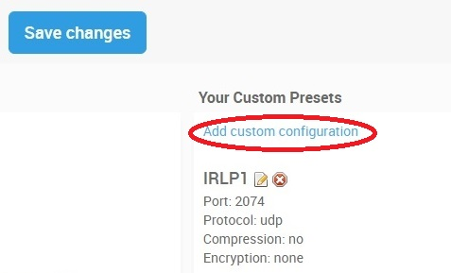

* 1. Next enter the needed settings for each port, repeat steps for each port required. Compression and scramble are not used, no encryption.

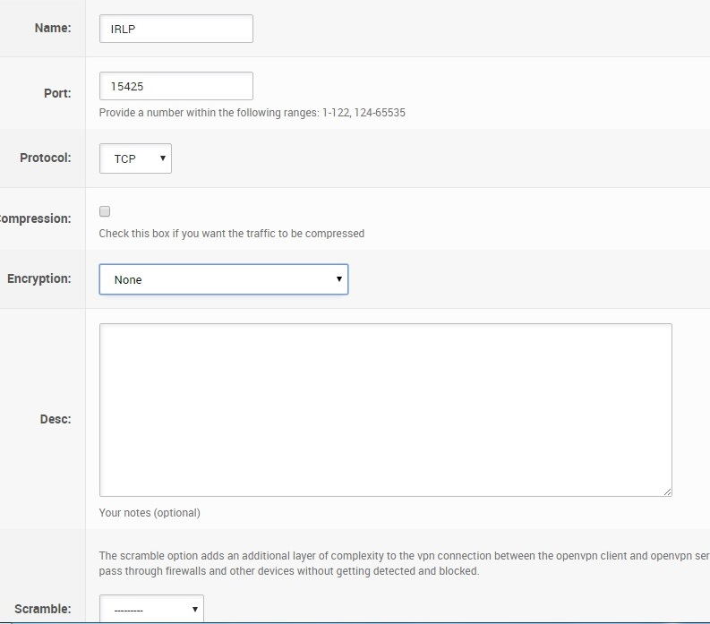

* 1. When all your settings are finalized go back to the main page and select GetOpen VPN Config File. Download the Computer Setup Config file.

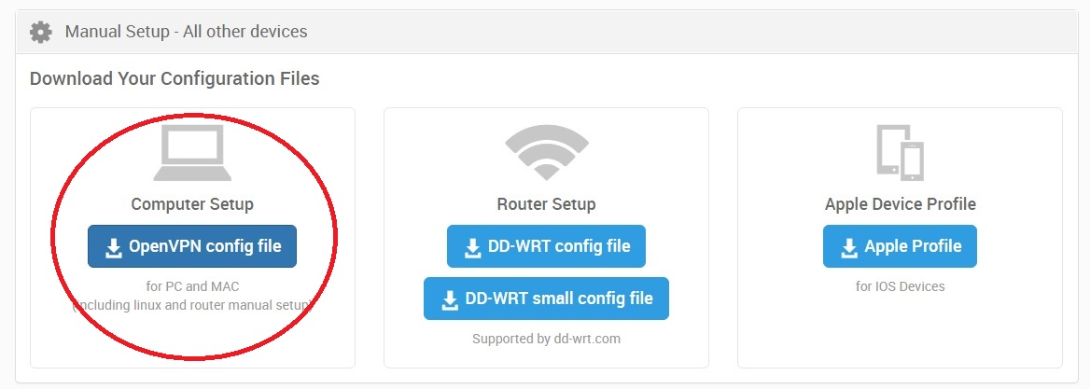

1. Follow these instructions from Strong VPN once the config file is loaded to your Pi, <http://strongvpn.com/setup-linux-openvpn.html> .
2. You should now be all setup and ready to rock. This is a simplified instruction sheet, if you need more help please make use of the Yahoo Pi IRLP board or you can also contact me via my node contact page through the IRLP site, node 8665.

Best of Luck

73’s